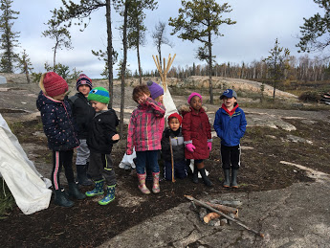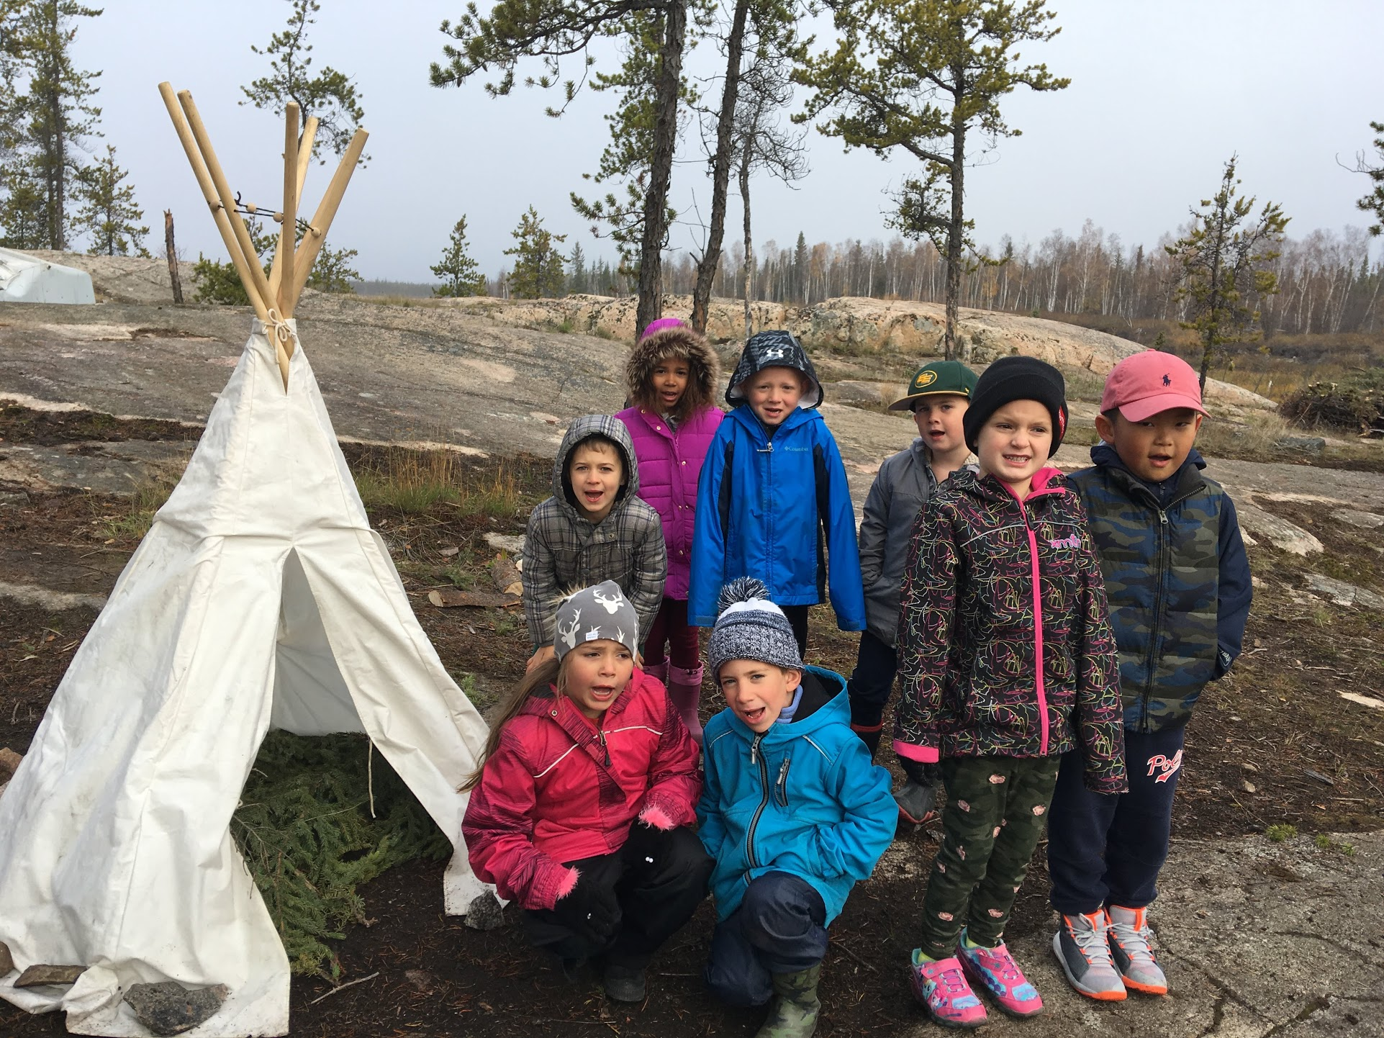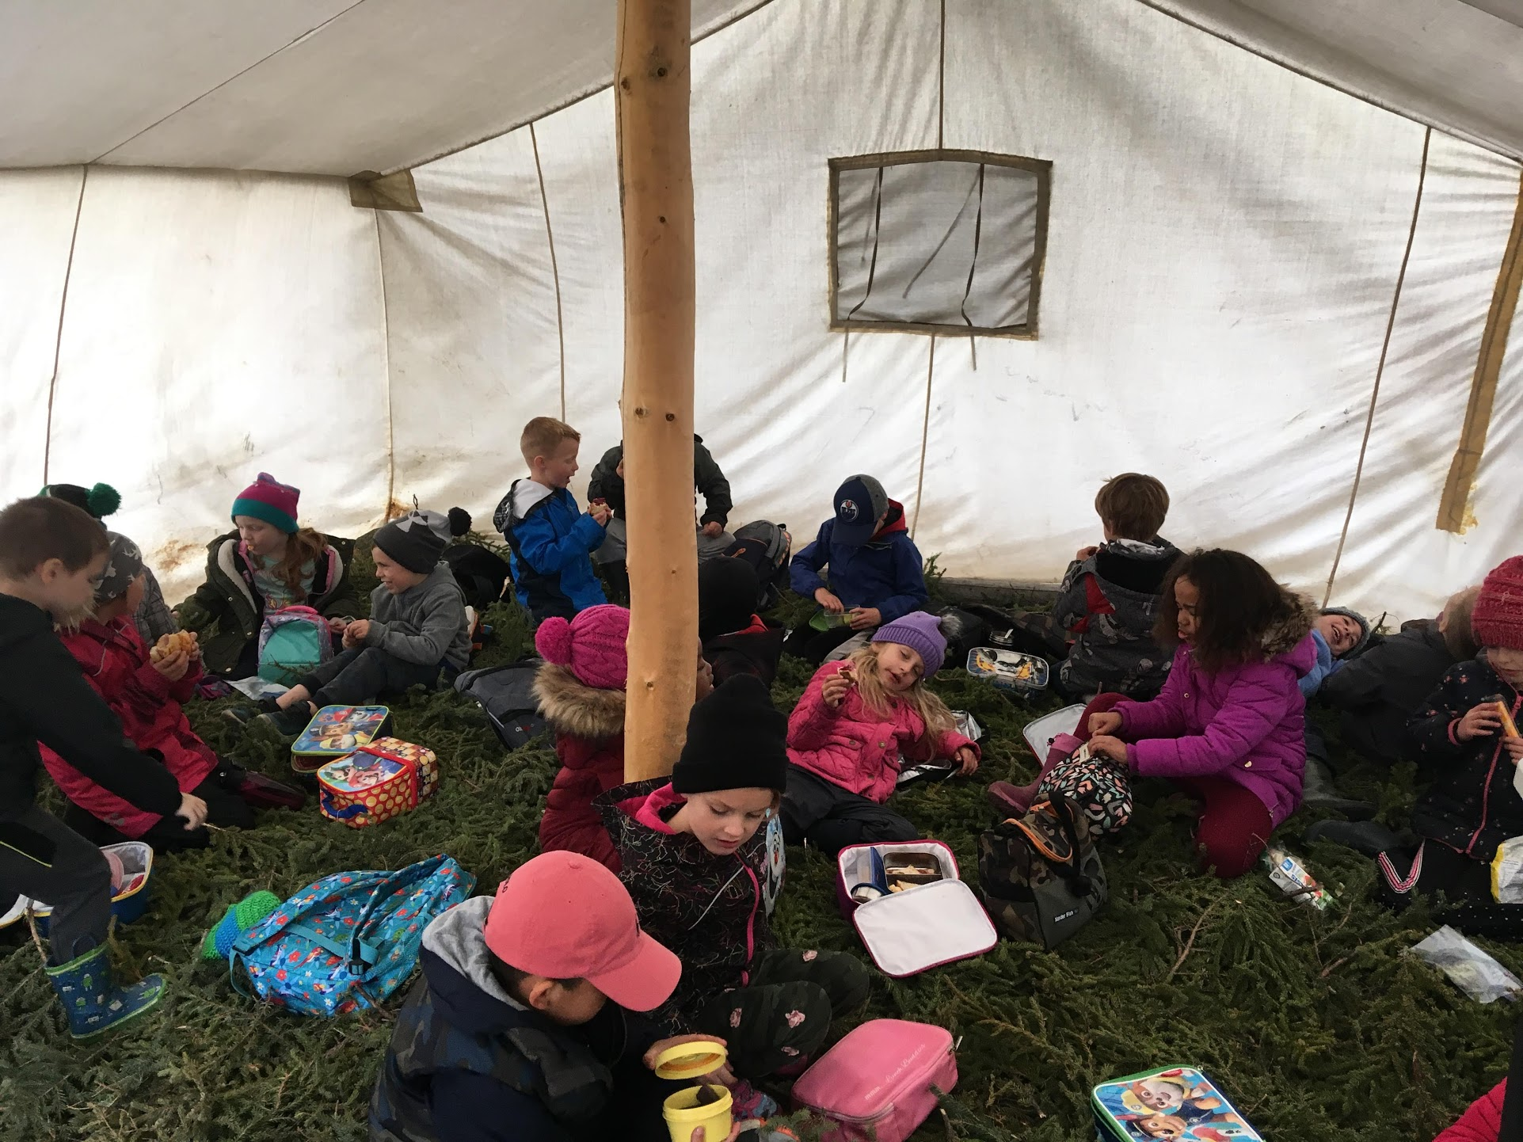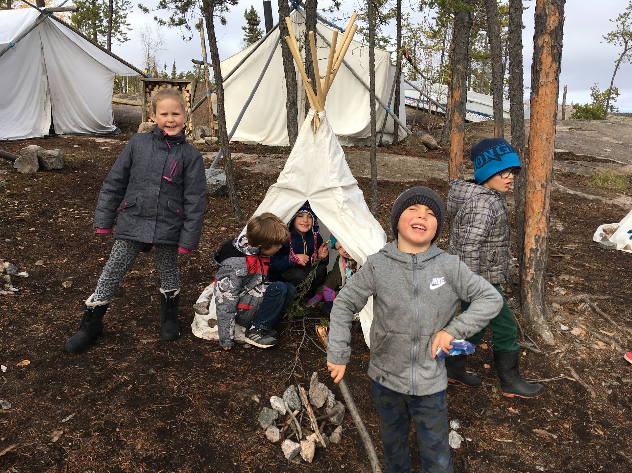

Mme. Berthier and her Amazing Grade 1 Class

September and October are the months of Xat’ô in Denedeh. It is a time of Fall Harvest when the berries and plants are ready to be gathered for the long winter ahead. Cranberries, juniper berries, crowberries, rosehips, and many of our northern berries are picked and dried or made into jams to last the winter.

Medicine plants are also ready to be harvested. Labrador tea grows in abundance in our Northern land and is used to make a tea that helps with colds and flus. The needles, the cones, and the sap (gum) of spruce trees are gathered to make medicine to prevent infections in sores or for skin ailments. Many Northern plants including rat root, willow and birch fungus were harvested as part of a traditional first aid kit.

When harvesting plants and medicines, it is important to leave an offering such as matches or tobacco to show gratitude for the gift of the plant.

Fall is a beautiful time of year in Denedeh. We are grateful for all the land provides.

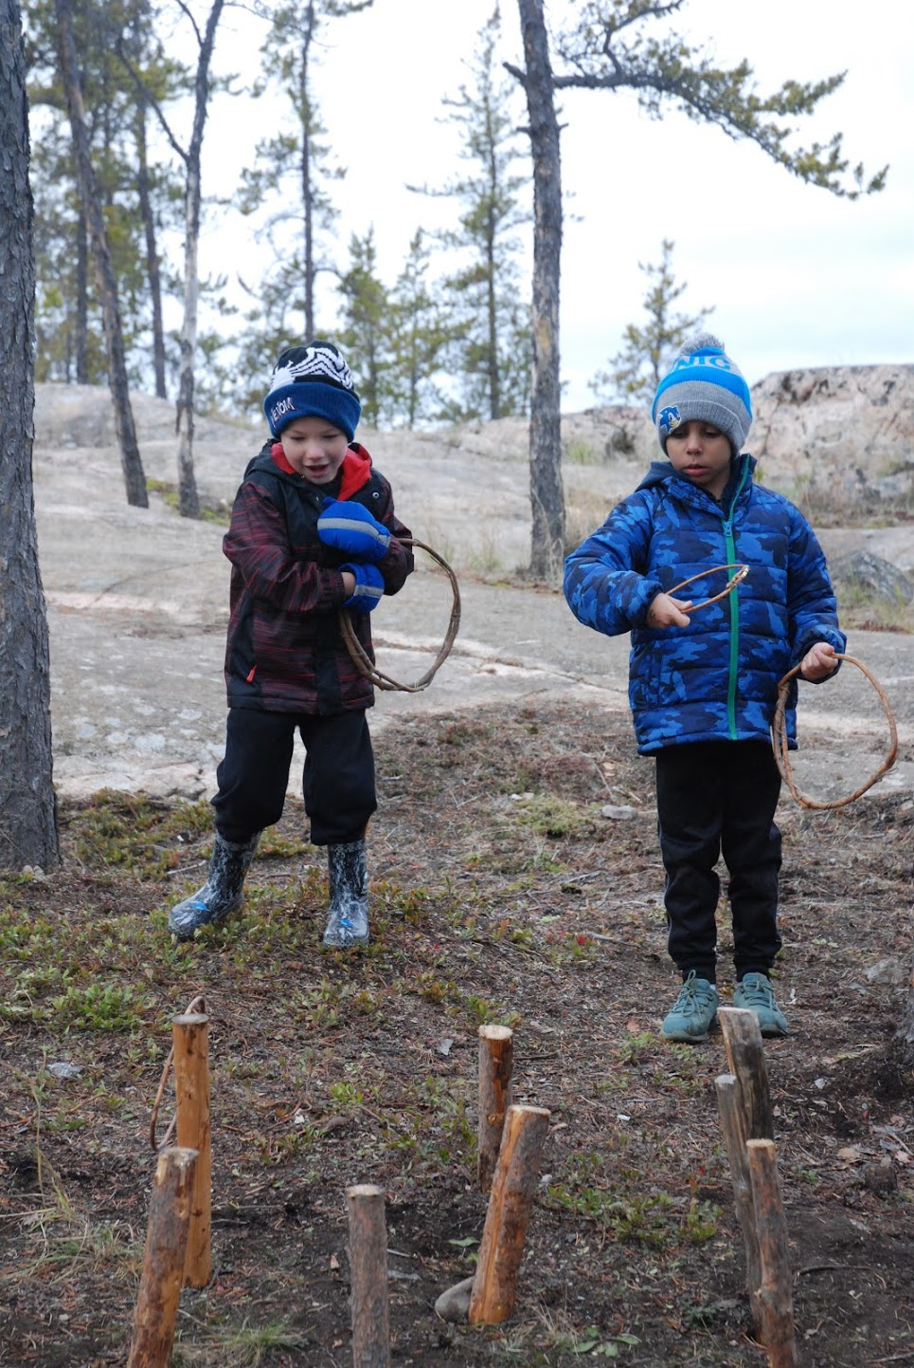



Plant and Earth Medicine Camp

Yellowknife Catholic Schools Xat’ô 2019

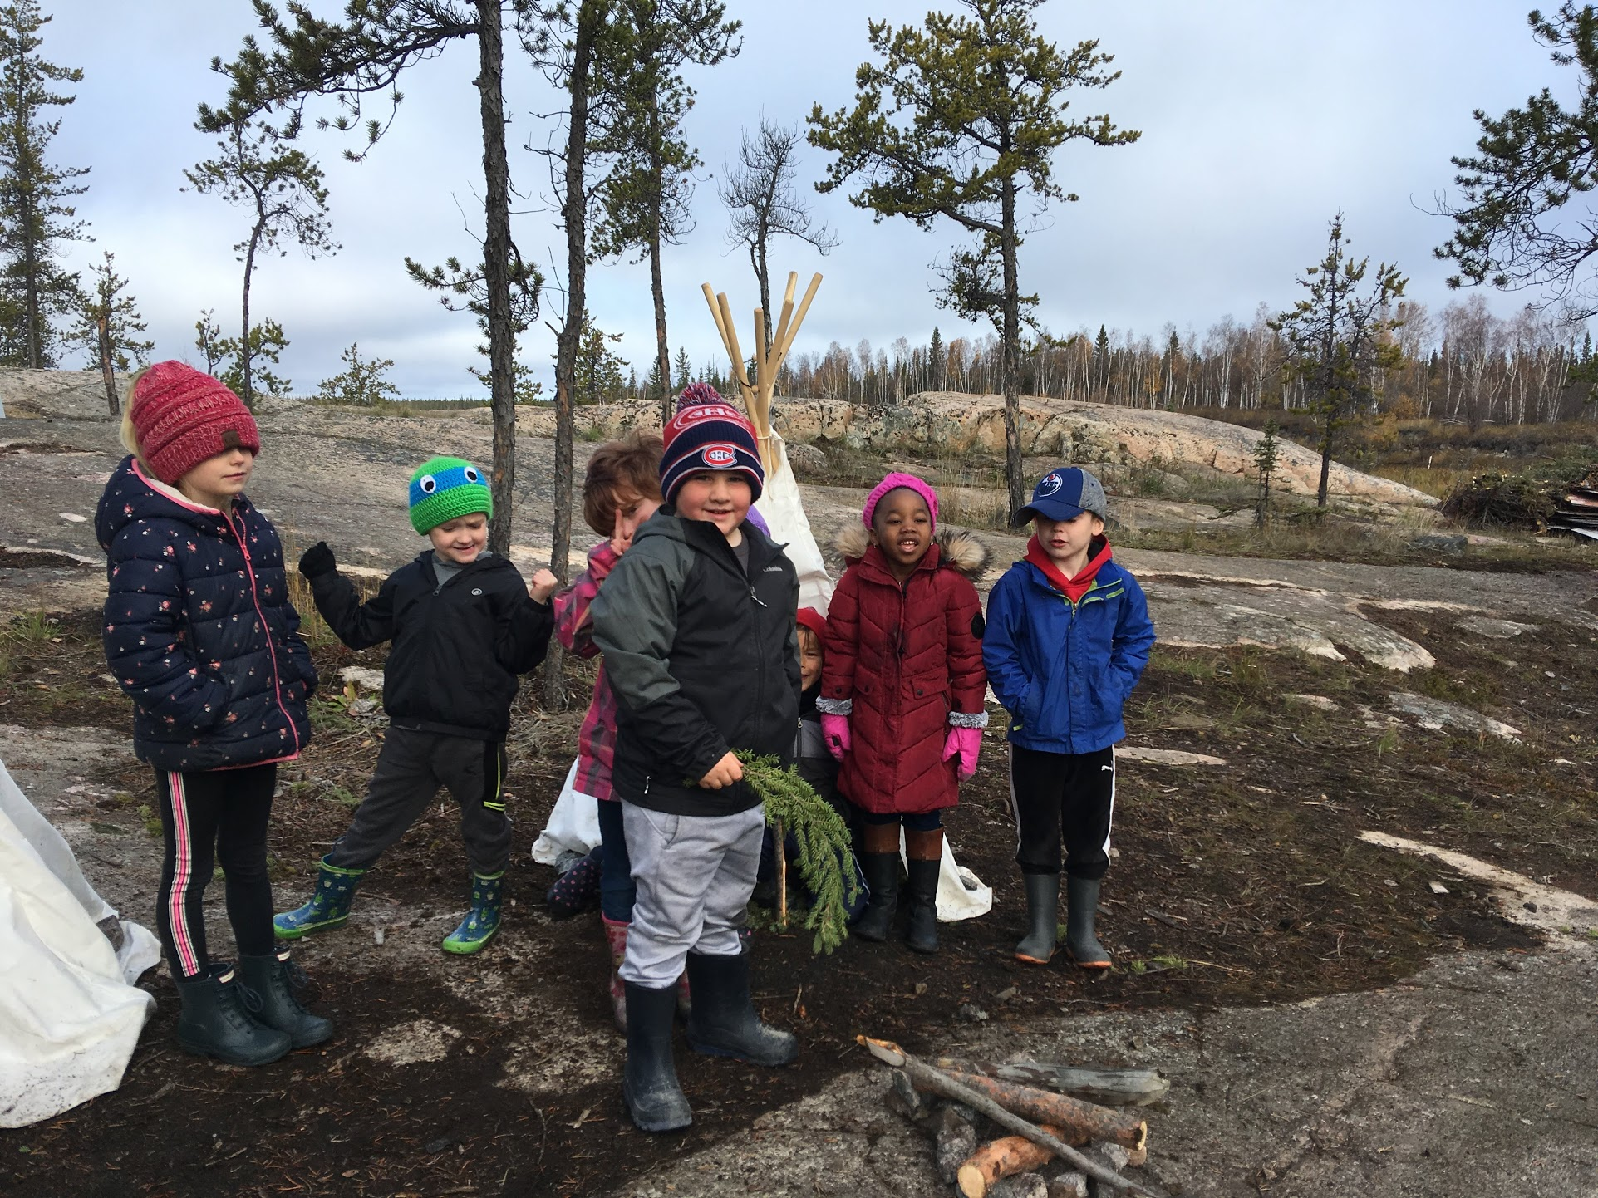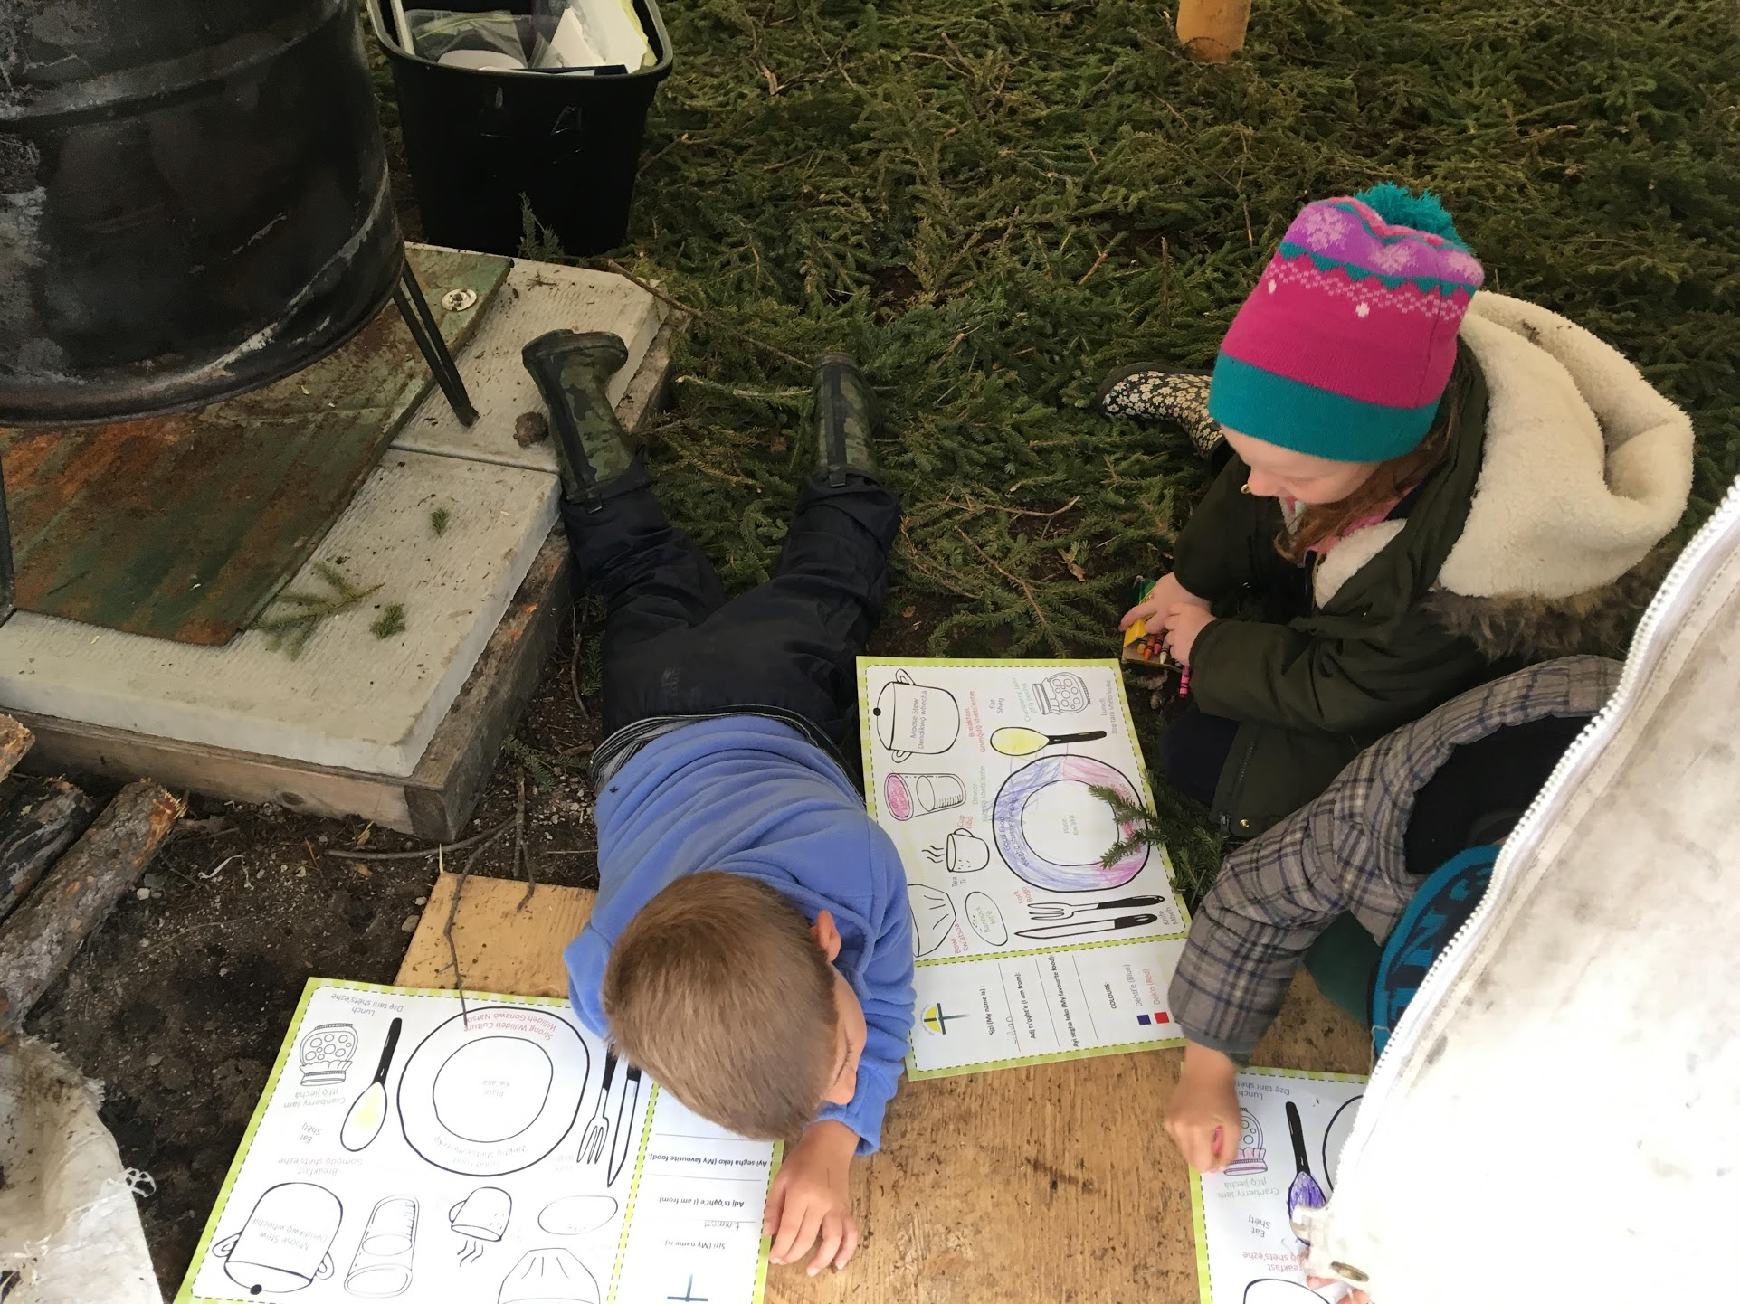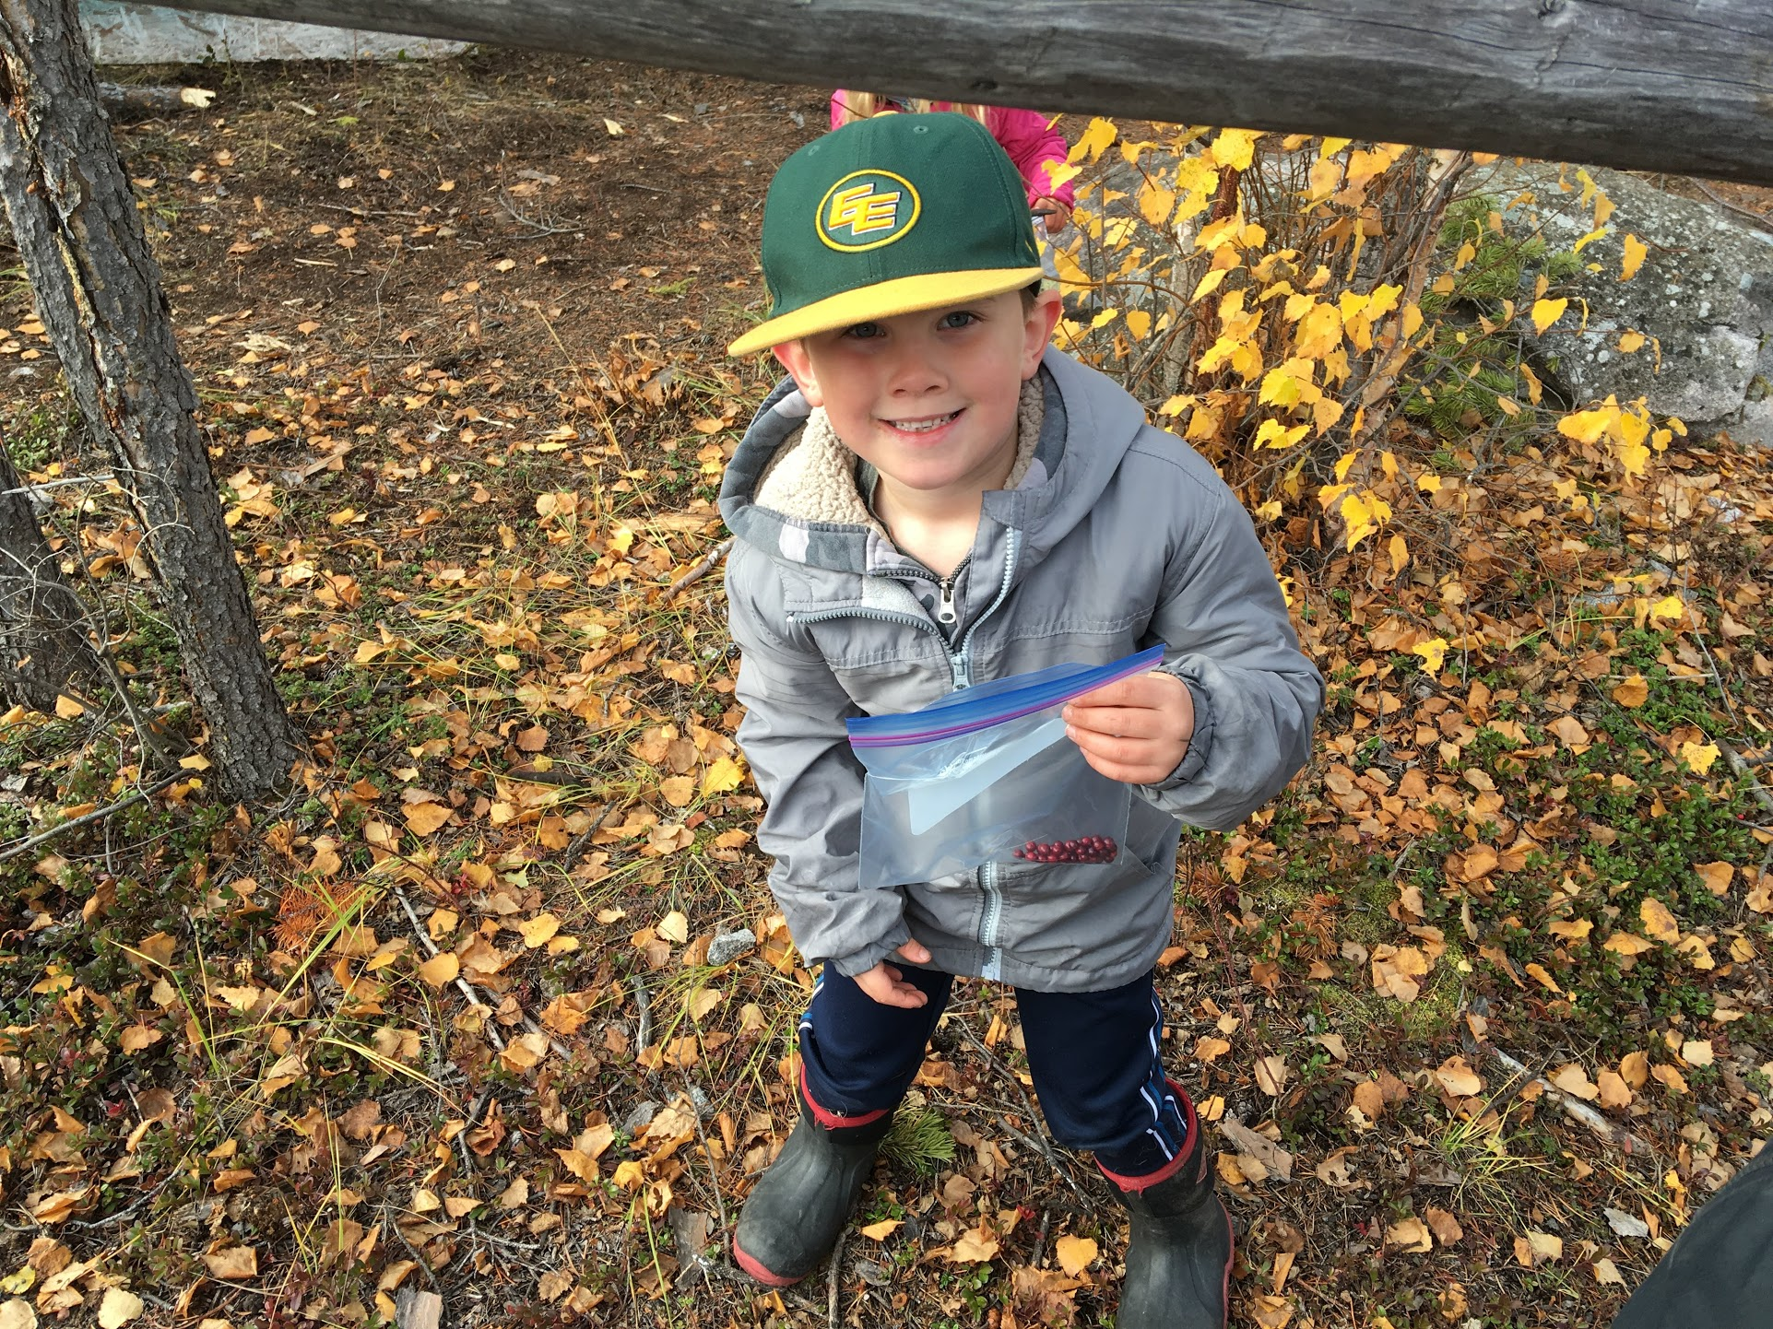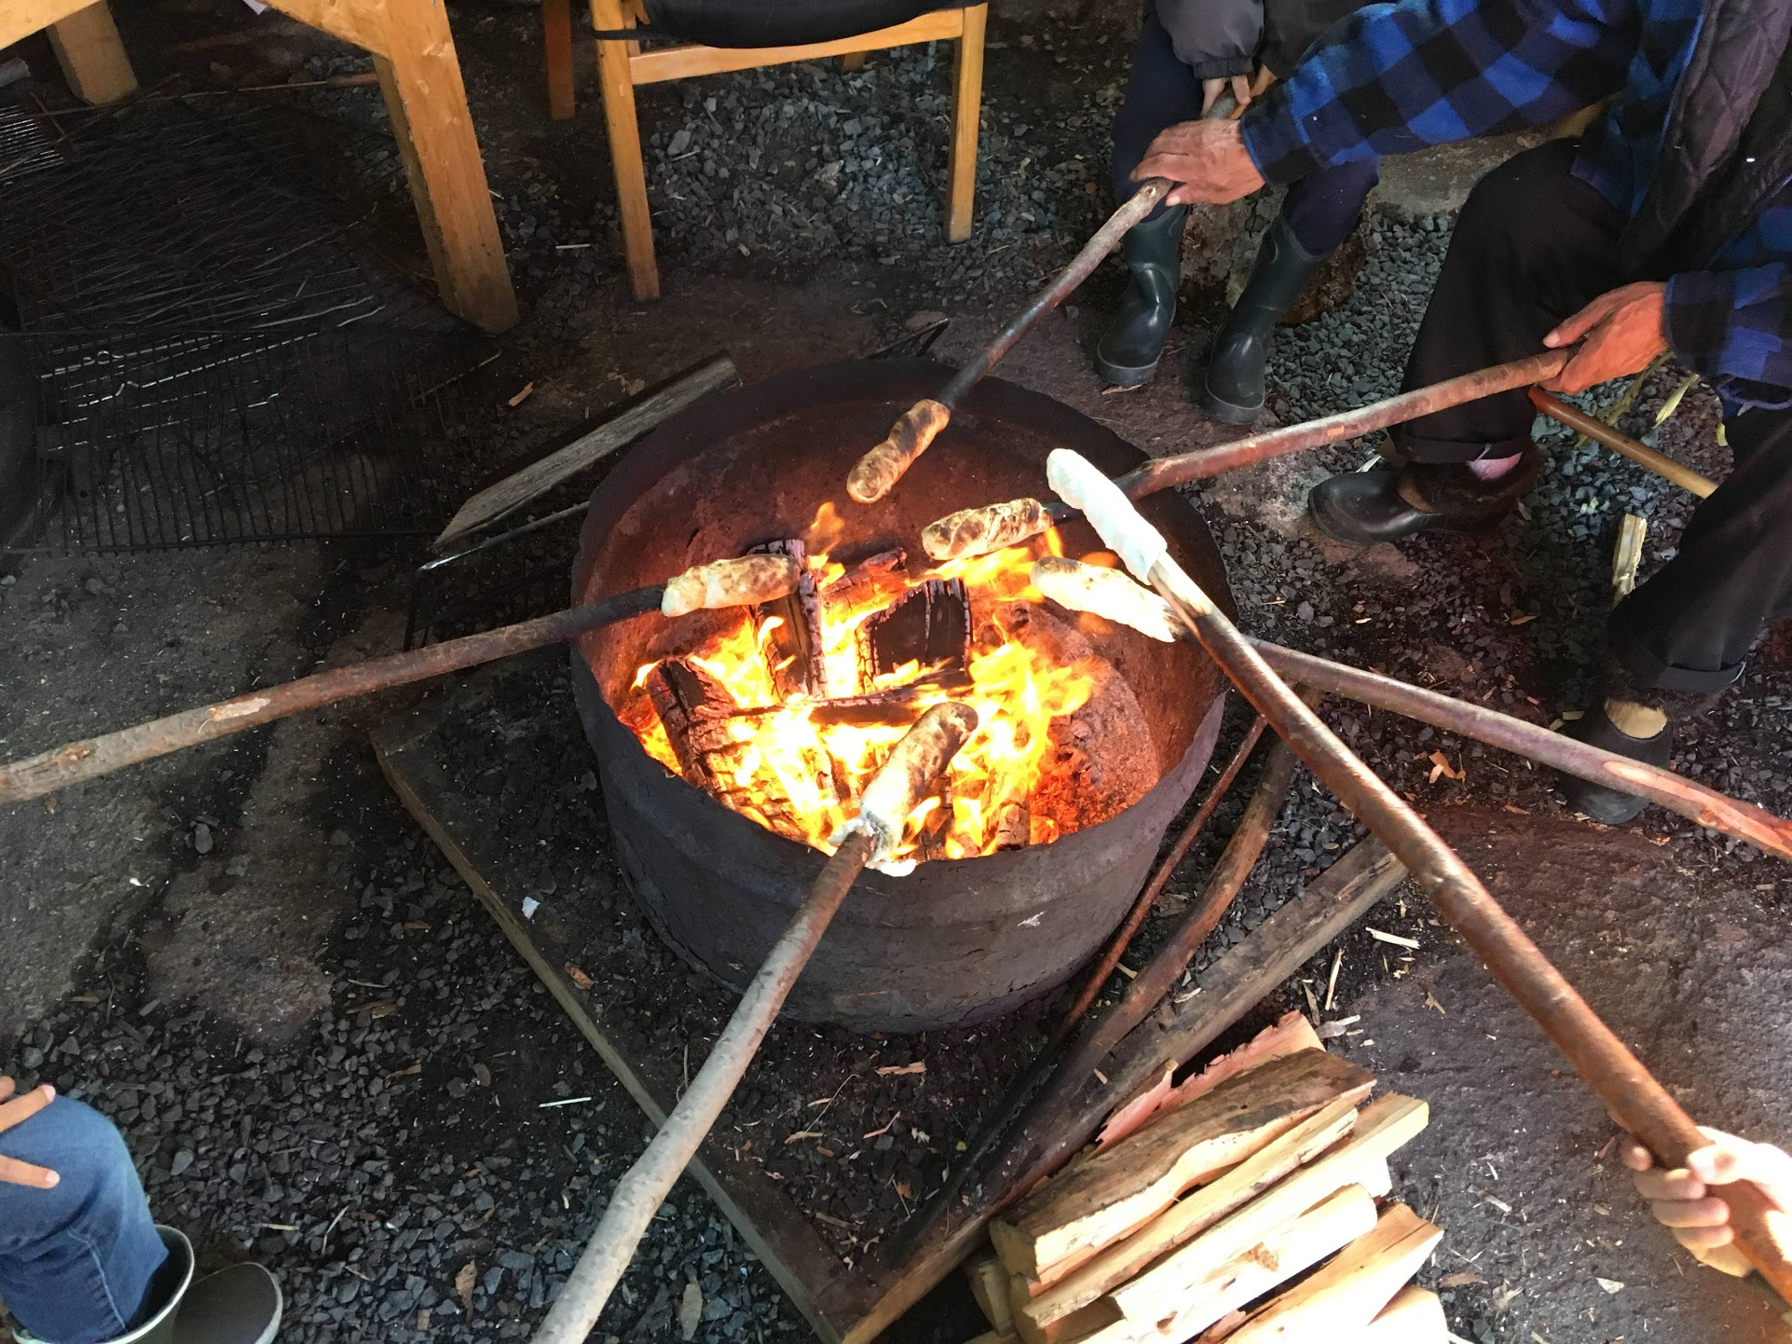

John Cosenzo was selected by our Elders to be a member of the Ecole St. Joseph School Husky pack because of his interest in learning about Plants and Earth Medicines. He continued picking cranberries during the Free Play time and showed pride in his harvesting skills. John demonstrated the Dene Law: “Sleep at night and work during the day.”

HUSKY P.A.C.K!

(Participation in Aboriginal Cultural Knowledge)

At Plant and Earth Medicine Camp

We began our day with a prayer and a Feed the Fire ceremony thanking the Creator for the blessings of the land and asking for help to keep us safe at our camp.

In the morning, we made bannock on a stick with the help of our Elders Mike and Verna Crapeau. We went on a nature walk to harvest cranberries and earth medicines. We learned how to set up a traditional campsite, and set up our own camps.

After lunch, we tasted Labrador tea. The afternoon activities included playing Dene games, going on a nature walk and learning our Wiliideh Yati words for jam, tea, fork, knife, cup, bowl, and plate.

At the end of our camp, we thanked our Elders, Mike and Verna, and our resource staff, Edward and Noel Doctor and Alex Martin.

# Our Words in Wilììdeh Yati:

jìechà jam kw’àtsoa bowl

lidì tea kw’àkà plate

libò cup îtå’ô cranberry

mbeh knife îchï rosehips

gots’agò lidì Labrador tea bògo fork